

**Operating System**

**Lab # 03**

**Name: Zainab Bibi**

**Sap Id: 46462**

**Batch: BSCS 5thsemester**

**Submitted to: Mam Kausar**

**Q1. Make the following directory (03 Marks)**

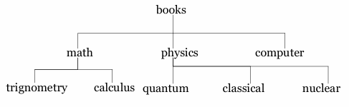

**Solution:**

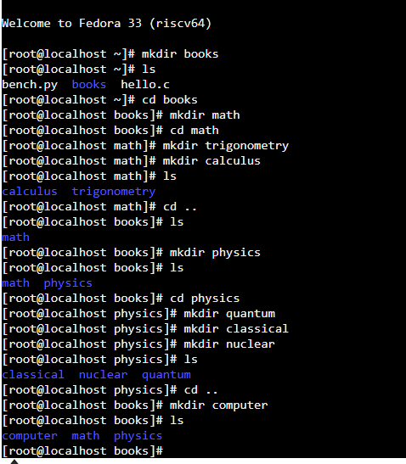

**Q2. Which are the Linux Directory Commands? Explain the understanding of commands in your own words. Also define what is BASH? (02 Marks)**

**Note: Include screenshots, where required to illustrate your explanation.**

**Solution:**

Commands in Linux are instructions you give to your computer through the terminal or command line. It’s like giving your computer specific tasks to do, using text instead of clicking with a mouse. For example:

**ls:** Tells the computer to show you what’s inside a folder.

**cd:** Tells the computer to move into a specific folder.

**mkdir:** Tells the computer to make a new folder.

**pwd:** Asks the computer to show you where you are currently working.

Each command is like a simple instruction or a small sentence that the computer understands and executes immediately.

**BASH (Bourne Again Shell)** is like a tool that helps you interact with your computer using text commands. Instead of clicking on icons or menus, you type commands, and BASH makes the computer do things like opening files, running programs, or creating folders. It’s commonly used in Linux and other Unix-based systems.

**Q3.**

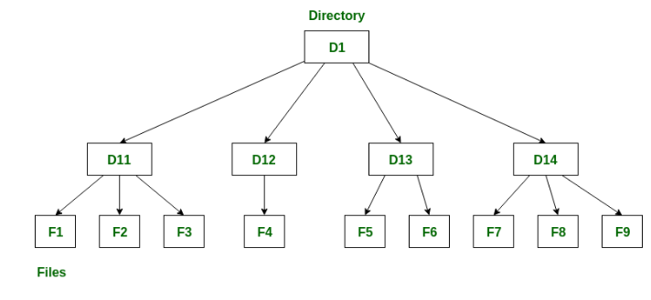

**Solution:**

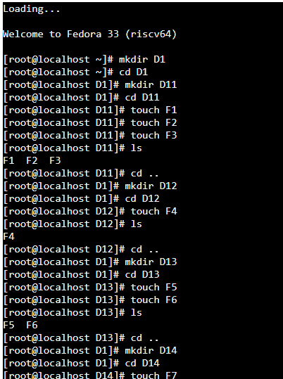

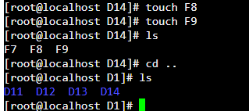

**Q4. Make the following directory (03 Marks)**

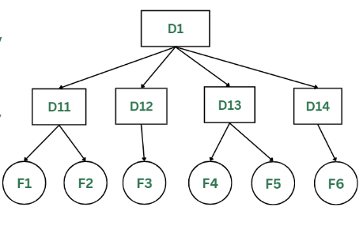

**Solution:**

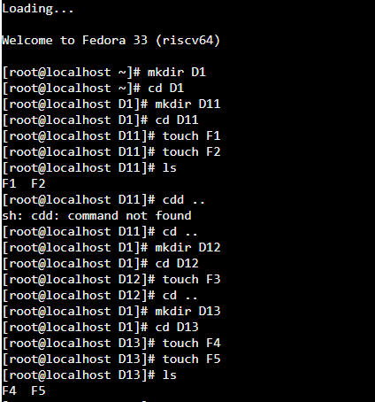

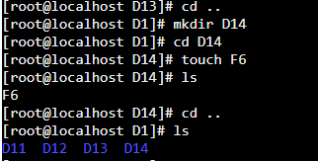



**THE END**